How to use the voting program for a Mac OSX.

- download the file voting.py
- move this file to your desktop. Make sure the name of the file is voting.py
- you are going to run the program now. The best way to do this is to use the Terminal (this is the functionality that lets geeky people do powerful stuff with their mac. Don't worry, you won't mess up anything.)
- Locate the program Terminal. There is a search bar at the top of your mac. I have included pictures. Type Terminal. When the application comes up on the search bar, click it to run it.



Note that I have clicked the magnifying glass on the top right and I typed in the word terminal.

Terminal looks like this
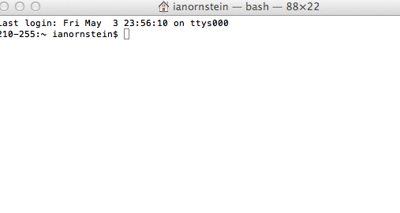
Note mine says ianornstein because this is my computer.

- You will now locate the file. Do this by typing the following commands
cd [ now push enter]
cd Desktop [now push enter. You are now in the desktop where the file is]

I've included the next step in this photo but I haven't pushed enter yet.

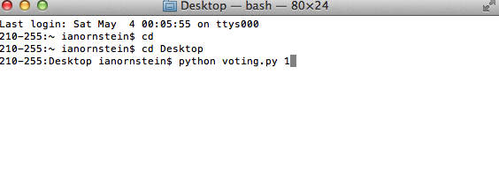

- run a test example by typing
python voting.py 1 [and push enter]

- to run the actual program type
python voting.py [and push enter]

